TASK 8
- Write a function named findMax that takes two integer parameters and returns the maximum of the two numbers. Then, in main(), input two numbers from the user and display the maximum using the function.
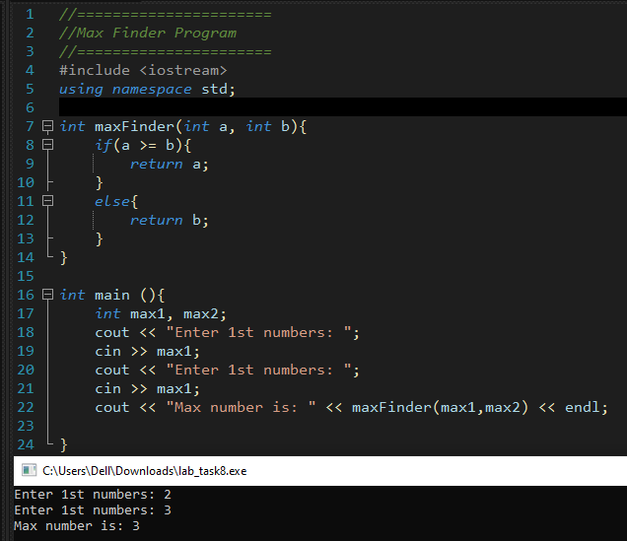

- Write a function named isEven() that takes an integer as a parameter and returns true if the number is even, otherwise false. In main(), input a number from the user and display whether it is even or odd.

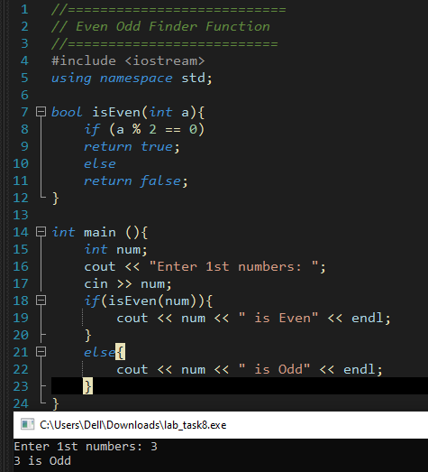

3) Write a function named findFactorial() that takes an integer n as a parameter and returns the factorial of that number. (The factorial of n is n × (n-1) × (n-2) × ... × 1)
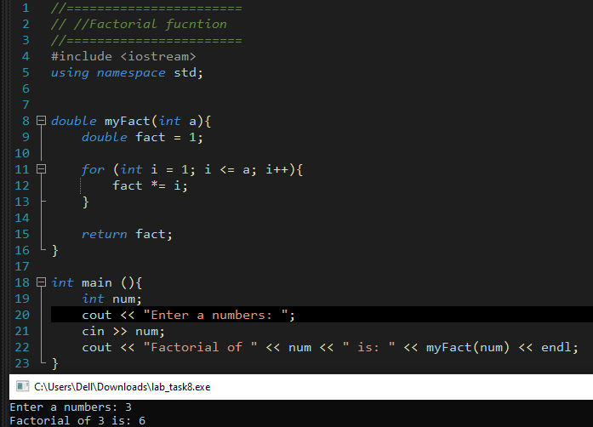

- Write a function named analyzeNumber() that takes an integer as input and returns both: the count of digits, and the sum of digits of that number.

